A Project Report on

**Internet usage**

Submitted in partial fulfillment of the requirements for the award of the degree of

**BACHELOR OF TECHNOLOGY**

in

**COMPUTER SCIENCE AND ENGINEERING**

Submitted by:

**SK.RIZWAN (21P31A05B5)**

**Under the esteemed supervision of**

**Mr./Mrs./Ms./Dr. Jalligampala Divya Lalitha Sri, M.Tech,PHD**

**professor**



**ADITYA COLLEGE OF ENGINEERING & TECHNOLOGY**

**Approved by AICTE, New Delhi & Affiliated to JNTUK, Kakinada**

**Accredited by NAAC (A+) and NBA**

**Surampalem, Kakinada District, Andhra Pradesh - 533 437**

**2021-2025**

# Community Service Project Report

*Submitted in accordance with the requirement for the degree of* …B.Tech……………

Name of the College : Aditya college of engineering and technology

Department : CSE

Name of the Faculty Guide : Mrs. J DIVYA LALITA SRI Duration

of the CSP: From ……22.08.2022……… To …..04.09.2022……

Name of the Student: SK . RIZWAN

Programme of Study: B . T e c h

Register Number: 21P31A05B5

Year of Study: 2nd year

Semester: 1st

Date of Submission:14-12-2022

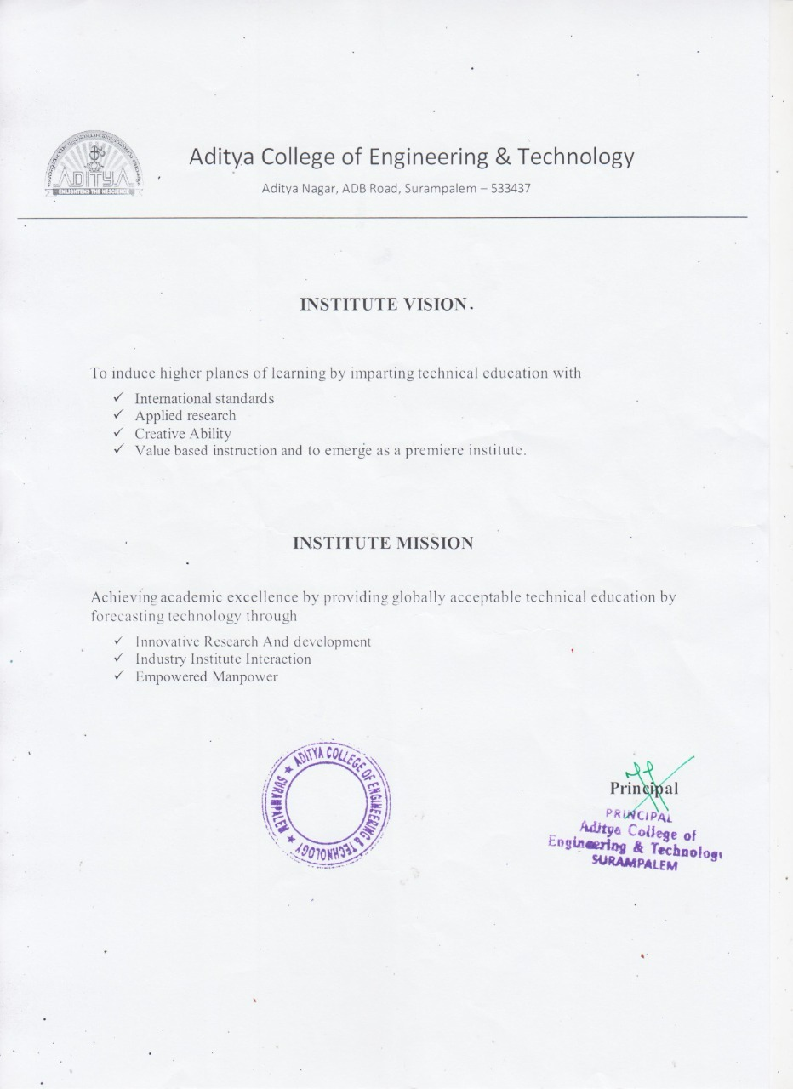

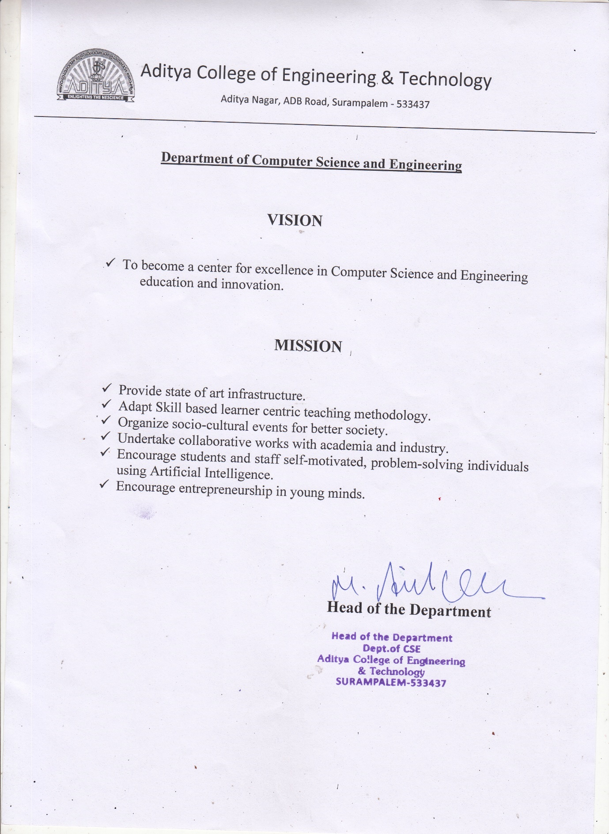

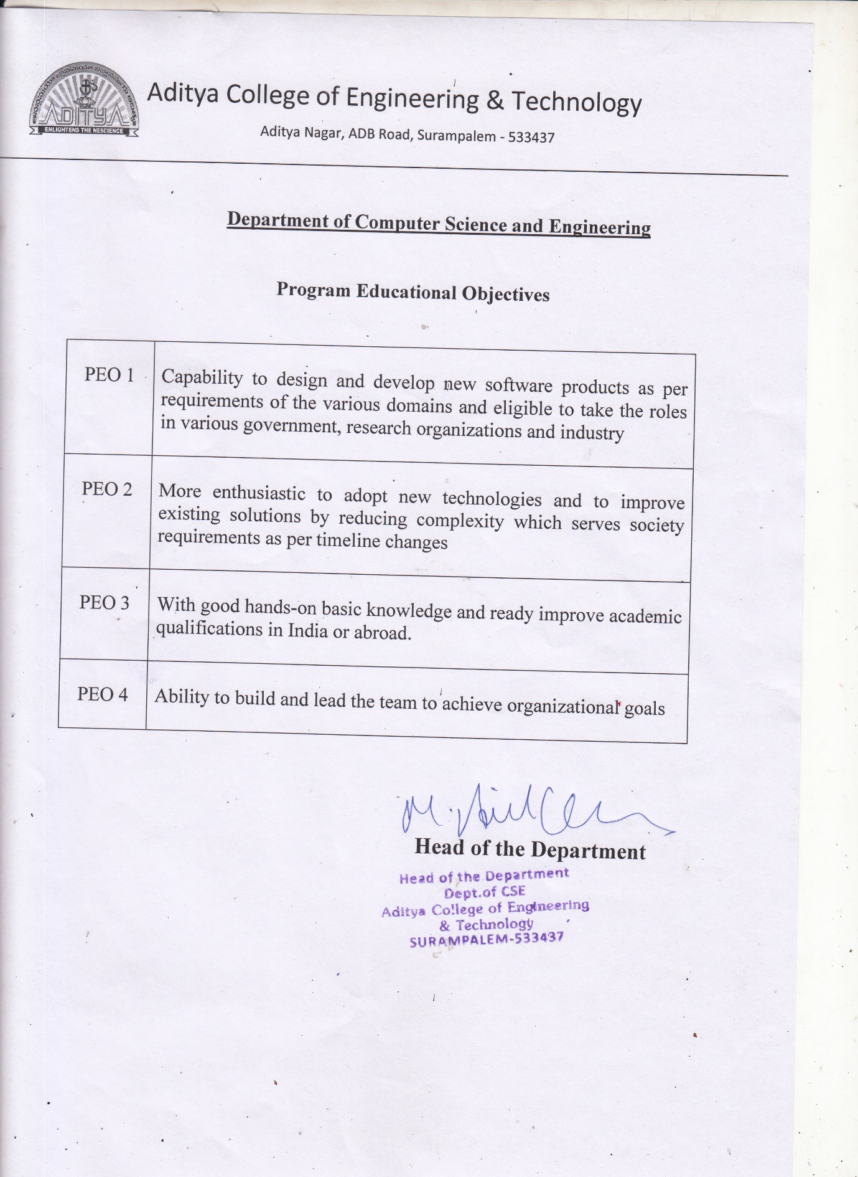

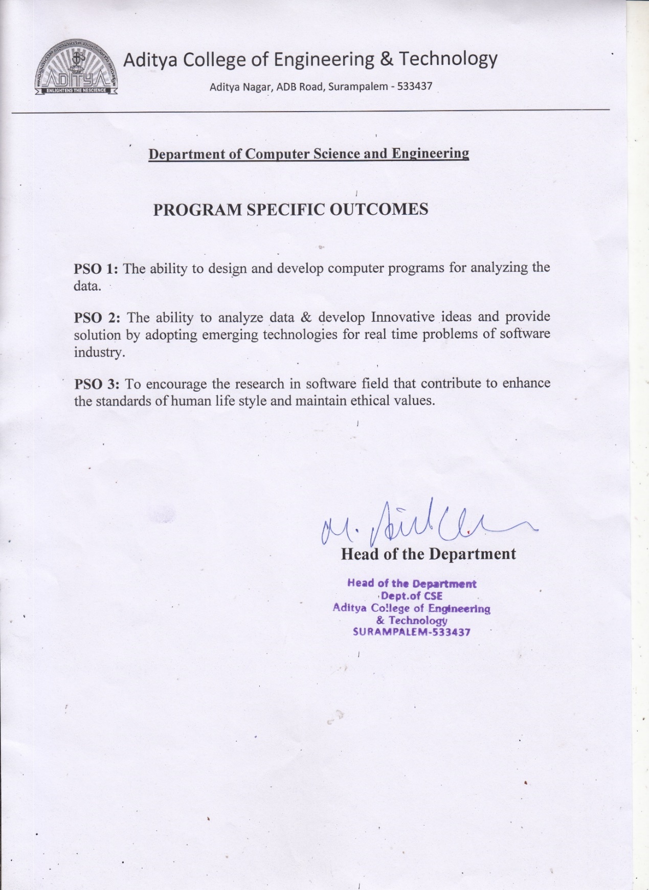

**ADITYA COLLEGE OF ENGINEERING & TECHNOLOGY**

Approved by AICTE, New Delhi & Affiliated to JNTUK, Kakinada

Accredited by NAAC (A+) and NBA

**DEPARTMENT OF COMPUTER SCIENCE AND ENGINEERING**



**CERTIFICATE**

This is to certify that the Community Service Project work entitled, **"Internet usage ",** is a bonafide work carried out by Sk.Rizwan**(21P31A05B5)**, in partial fulfillment of the requirements for the award of the degree of **BACHELOR OF TECHNOLOGY** in **COMPUTER SCIENCE AND ENGINEERING** from **Aditya College of Engineering and Technology**, Surampalem, during the academic year 2022-2023.

This project work has not been submitted in full or part to any other University or Educational Institute for the award of any Degree or Diploma.

|  |  |  |
| --- | --- | --- |
| **PROJECT SUPERVISOR**  Mrs. J.DIVYA LALITA SRI  MTech., Ph.D. Professor |  | **HEAD OF THE DEPARTMENT**  Dr.M.Anil Kumar  MTech., Ph.D. Professor |

# EXTERNAL EXAMINER

# Student’s Declaration

I **Sk.Rizwan** a student of **B.Tech** Program, Reg.No. **21P31A05B5** of the Department of **Computer Science and Engineering**, **Aditya College of Engineering & Technology (P3)** College do hereby declare that, I have completed the mandatory community service project from **22.08.2022** to **04.09.2022** in **RAMESAMPETA** under the Faculty Guideship of **J.DIVYA LALITA SRI**, **Computer Science and Engineering**, **Aditya College of Engineering & Technology (P3).**

***(Student Signature and Date)***

**Endorsements**

*Faculty Guide*___ J.DIVYA LALITA SRI______________________

*Head of the Department* Dr.M.Anil Kumar

# Certificate from

# Official of the Community

This is to certify that **Sk.Rizwan** *(Name of the Community Service Volunteer)* Reg.No. 21P31A05B5 of Aditya College Of Engineering and technology (Name of the College) underwent community service in RAMESAMPETA *(Name of the Community)* from 22.08.2022 to 03.09.2022. The overall performance of the Community Service Volunteer during his/her community service is found to be good *(Satisfactory/Good).*

***Authorized Signatory with Date and Seal***

**ACKNOWLEDGEMENTS**

It is with immense pleasure that we would like to express our indebted gratitude to my **project supervisor**, **Mr./Mrs./Ms./Dr.** **J.DIVYA LALITA SRI**, PHD who has guided us a lot and encouraged us in every step of project work, his valuable moral support and guidance has been helpful in successful completion of this Project.

We wish to express our sincere thanks to **Dr.M.ANIL KUMAR** M.Tech.,Ph.D., **Head of the Department of CSE**, for his valuable guidance given to us throughout the period of the project work.

We feel elated to thank **Dr.A.RAMA KRISHNA** M.Tech.,Ph.D., **Dean (Academics & Administration)** of Aditya College of Engineering and Technology for his cooperation in completion of our project work.

We feel elated to thank **Principal**, **Dr.DOLA SANJAY S** M.Tech.,Ph.D., of Aditya College of Engineering and Technology for his cooperation in completion of our project and throughout our course.

We wish to express our sincere thanks to all faculty members, and lab programmers for their valuable guidance given to us throughout the period of the project.

We avail this opportunity to express our deep sense and heart full thanks to the **Management** of **Aditya College of Engineering & Technology** for providing a great support for us by arranging the trainees, and facilities needed to complete our project and for giving us the opportunity for doing this work.

|  |
| --- |
| **STUDENT NAME** |
| **Sk.Rizwan(21P31A05B5)** |

**ABSTRACT**

Networking is the lifeblood of any community, online or offline – it's how we turn a one-way flow of information into collective intelligence. By fostering connections in your online community, you develop a space where people can meet to share their knowledge, ask questions, and get support for their work

**INTERNET USAGE:**

As a growing trend in the world, internet-based research has become vital in one's daily life. The internet use by students has increased dramatically in recent years and also surfing the internet has become an important part of general student life. Furthermore, information technologies (IT) have greatly expanded into the field of education in last two decades. The aim of this research is to summarize the internet usage patterns of undergraduate students and to show in what density students utilize from internet sources for educational purposes. In accordance with this aim, we examined and reported their internet usage patterns and main purposes of using IT with a field survey. As a result of this research, it was aimed to state a general profile of the students reflecting their practices towards internet usage. At the same time, this study reveals that using information technologies make students not just to consume technology but also lead them to produce it. Shortly, spending long hours during online might be helpful for young to make some contributions to their knowledge about information technologies and unlike some people's prejudices, surfing internet is not totally waste of time for students but more or less a productive facility.

**CONTENTS**

|  |  |  |
| --- | --- | --- |
| **CHAPTER** | | **PAGE No.** |
| **ABSTRACT** | | **Xi** |
| **LIST OF FIGURES** | | **Xiv** |
| **LIST OF TABLES** | | **Xv** |
| **1**. **EXECUTIVE SUMMARY** | |  |
| 1.1 | Brief description of the Community |  |
| 1.2 | Summary of all the activities |  |
| 1.3 | learning objectives |  |
| 1.4 | Project outcomes |  |
| **2**. **OVERVIEW OF THE COMMUNITY** | |  |
| 2.1 | Historical profile of the community / habitation |  |
| 2.2 | Community diversity |  |
| 2.3 | Traditions at community |  |
| 2.4 | Community ethics and values |  |
| 2.5 | Brief note on Socio-Economic conditions of the Community |  |
| **3**. **COMMUNITY SERVICE PART** | |  |
| 3.1 | Activities undertaken in the Community |  |
|  | 3.1.1 Activity log for the First week |  |
|  | 3.1.2 Weekly Report of Week-1 |  |
|  | 3.1.3 Activity log for the Second week |  |
|  | 3.1.4 Weekly Report of Week-2 |  |
|  | 3.1.5 Activity log for the Third week |  |
|  | 3.1.6 Weekly Report of Week-3 |  |
|  | 3.1.7 Activity log for the Fourth week |  |
|  | 3.1.8 Weekly Report of Week-4 |  |
|  | 3.1.9 Activity log for the Fifth week |  |
|  | 3.1.10 Weekly Report of Week-5 |  |
|  | 3.1.11 Activity log for the Sixth week |  |
|  | 3.1.12 Weekly Report of Week-6 |  |
| 3.2 | Skills acquired during the project |  |

|  |  |  |
| --- | --- | --- |
| **4. OUTCOMES DESCRIPTION** | |  |
| 4.1 | Details of the Socio-Economic Survey of the Village/Habitation |  |
| 4.2 | Questionnaire prepared for the survey |  |
| 4.3 | Problems identified in the community |  |
| 4.4 | Short-term and Long-term action plans for possible solutions |  |
| 4.5 | Community awareness programme(s) conducted |  |
| 4.6 | Report of the mini-project work done |  |
| **5. RECOMMENDATIONS AND CONCLUSIONS OF THE MINI PROJECT** | |  |
| **6. POWER POINT PRESENTATION SLIDES** | |  |
| **7. STUDENT SELF-EVALUATION FOR THE CSP** | |  |
| **8. EVALUATION BY THE PERSON IN-CHARGE IN THE COMMUNITY / HABITATION** | |  |
| **9. PHOTOS & VIDEO LINKS** | |  |
| **10. INTERNAL ASSESSMENT STATEMENT** | |  |

|  |  |  |  |
| --- | --- | --- | --- |
|  | **LIST OF FIGURES** | |  |
| **S.No.** | **NAME OF FIGURE** | | **PAGE No.** |
| 1 | 1.1 Geographical Location of Community |
| 2 | 1.2 Survey Form |
| 3 | 3.1 Graphical Representation of Problem |
| 4 | 4.1Campaigning |
|  |  |
| 5 | 4.2 Photos and Videos link | | X |

|  |  |  |  |
| --- | --- | --- | --- |
|  | **LIST OF TABLES** | |  |
| **S.No.** | **NAME OF TABLE** | | **PAGE No.** |
| 1 | * 1. Activity log for first week |
| 2 | 1.2 Activity log of second week |
|  |  |

## 1. EXECUTIVE SUMMARY

## 1.1)Description of community :

Ramesampeta is a village in Rajavommangi Mandal , Alluri Sitharaman Raju district

Of Andhra Pradesh . It is located 27km from District headquarters, Kakinada. The village is about 370 families live in this village .Paddy and vegetables are the main cultivating crops in that village

**1.2) SUMMARY OF ACTIVITIES DONE:**

* Finding the village that is suitable for my project
* Conducted the survey by preparing a form that is useful for gathering information from the people about the internet source around them
* From the information I found the major problems the people while using the internet and educating them about the uses of internet in there daily life
* Conducted the Awareness campaign in the village based in their problems

**1.3) Learning Objectives:**

• To sensitize the students to the living conditions of the people who are around

them,

• To make students aware of their inner strength and help them to find new

out of box solutions to the social problems.

• Provides opportunity to become active member of the community

• Enables to acquire life skills and knowledge, as well as provide a service to

those who need it most.

• To help students to initiate developmental activities in the community in

coordination with public and government authorities.

**1.4)Outcomes:**

• Improved social responsibility and citizenship skills.

• Improves students’ ability to apply what they have learned in “the real world.”

• Greater interpersonal development, particularly the ability to work well with

others, and build leadership and communication skills.

## 2. OVERVIEW OF THE COMMUNITY

## Ramesampeta is very large village in surampalem of East Godavari district, Andhra Pradesh with total 847 families residing. The while 545 are females as per population census of 2011.

## In ramesampeta village population of children with age 0-6 in 332 which makes up 10.22% of total population of village. Average sex ratio of Ramesampeta village is 983 which is lower than Andhra Pradesh state average of 993.child sex ratio of Ramesampeta as per census is 919 lower than Andhra Pradesh Average of 939.

## Ramesampeta village has lower literacy rate compare to Andhra Pradesh. In 2011 literacy rate of was 53.56% compared to 60.59%of Andhra Pradesh in ramesampeta literacy stand at 61.38%while female literacy rate was 35.90%.

## Ramesampeta village has population of 2345 of which 1800 are male

## 

|  |  |  |  |
| --- | --- | --- | --- |
| PARTICULARS | TOTAL | MALE | FEMALES |
| Total no. of houses | 845 |  |  |
| Population | 2345 | 1800 | 545 |
| Child(0-6) | 332 | 173 | 159 |
| Schedule caste | 300 | 146 | 154 |
| Schedule tribe | 206 | 107 | 99 |
| Literacy | 53.565% | 61.38% | 35.90% |
| Total workers | 883 | 575 | 308 |

## 3. COMMUNITY SERVICE PART

Description of the Activities undertaken in the Community during the Community Service Project. This part could end by reflecting on what kind of values, life skills, and technical skills the student acquired.

Throughout our community service project the activities taken under community was under the guidance of our project leader, members and our project supervisor. The first step towards in this First activity was we went to tower near the village we interacted with people and came to conclusion that development of the internet is low around some places in the village.

Second activity was that we went to middle of the village to check if there is any signal is low or good enough to use the internet.

Third activity we ask about network availability to some people around the place we visited.

Fourth activity we went to the houses of the ramesampeta village and conducted a survey to know how much they know about internet and it's importance .

Fifth activity was to create awareness among people that by using internet they can know about the world and learn anything in the internet open source.

Sixth activity was to know which network source they are using most people of ramesampeta.

Seventh activity was to create awareness among people in ramesampeta about internet advantages and the problems of spending more time on internet like radiation .

**ACTIVITY LOG FOR THE FIRST WEEK**

|  |  |  |  |
| --- | --- | --- | --- |
| **Day**  **&**  **Date** | **Brief description of the daily**  **Activity** | **Learning Outcome** | **Person In- Charge Signature** |
| Day – 1 | On the first day, we have formed the  team and decided the team head. | Team |  |
| Day - 2 | On the second day, we have explored  different topics and selected a topic | Topic |  |
| Day – 3 | We have taken the suggestions from  our Seniors about community service project. | Suggestions and guidance  from seniors. |  |
| Day – 4 | Started gathering the information  about the topic which has been  chosen. | Information about the  Topic. |  |
| Day – 5 | On the fifth day, we have searched  for the regions where most used internet  ratio near our place. | Research about the places**/**  regions. |  |
| Day – 6 | Went to visit the place that has been  Selected | Just visited the place |  |

**WEEKLY REPORT**

**WEEK – 1 (From Dt………..….. to Dt )**

|  |  |
| --- | --- |
| **Objective of the Activity Done** | Team formation and deciding of Topic |
| **Detailed Report** | We decided to start the project was started on . The main of the CSP Project is to make students socially responsible citizens who are sensitive to the needs of the disadvantaged sections. To help students to initiate  developmental activities in the community in coordination with public and government authorities. On the first we have decided the team mates and next day  we have decided the team head. We have gathered the information of the topic. The  chapter-1 is completely about the summary of the project. The main of aim of  Choosing this topic to bring awareness on the internet usage |

**ACTIVITY LOG FOR THE SECOND WEEK**

|  |  |  |  |
| --- | --- | --- | --- |
| **Day & Date** | **Brief description of the daily activity** | **Learning Outcome** | **Person In- Charge Signature** |
| Day – 1 | On we have visited ramesampeta and asked the people about the usage of internet and their response on the network problems | Interacting with people and their problems |  |
| Day - 2 | On again we have visited ramesampeta to collect some more details about the usage of internet | Deep about their problems on network |  |
| Day – 3 | On the next day we went to a network tower near the ramesampeta to know that how far the tower located | Main source o |  |
| Day – 4 | On also visited some houses to know that how many is aware about the uses of internet in their daily life | Educating the people about the usage of internet |  |
| Day – 5 | We have made the complete report  of the entire week. | Report |  |
| Day – 6 | On we have completed the documentation of the entire week that has been recorded | Documentation |  |

**WEEKLY REPORT**

**WEEK – 2 (From Dt………..….. to Dt )**

|  |  |
| --- | --- |
| **Objective of the Activity Done:** | To know more about the usage of internet in the village |
| **Detailed Report:** | On the second day, we had interacted with village sarpanch to On the second day , we had interacted with the village sarpanch to take the permission regarding conduction of project and taken the data from the sachivalayam staff about acres of land and number of network towers around the village and how many number of houses with the collected information. |

**4. OUTCOMES DESCRIPTION**

# 4.1)Socio-Economic Survey of the Village/Habitation

# Data collection using prescribed formats:

Data collection is the systematic process of gathering observations or measurements in research. The key to successful data collection is to construct easy to use forms and collect suggestion and unambiguous data that faithfully represent the source.

We collected data by using google forms and we provided options for the each and every question and approximately we created thirty questions for the villagers based on the water facilities and access to safe drinking water and we got many responses for the questions of our enquiry.

The data of the villagers is collected in a record book such that their name, locality etc., we recorded each and every person review separately in a log book by asking them questions by using the google forms. The villagers responded positively towards the questionnaire.

**4.2)Questionnaire prepared for the survey:**

We have conducted the survey in the village of ramesampeta we have prepared for the survey is of the following method

1. NAME : ____________
2. OCCUPATION : ____________
3. AGE :

* LESS THAN 18
* 18 -24
* 25 -35
* 36 – 60
* Above 60

1. DO YOU AWARE ABOUT INTERNET USAGE

* YES
* NO

1. DO YOU HAVE ANY EMAIL
2. WHICH PROVIDER/SIM YOU ARE USING FOR INTERNET ACCESS

* JIO
* AIRTEL
* BSNL
* VODAPHONE
* OTHER

1. HOW MANY MEMBERS USE INTERNET IN YOUR FAMILY

**4.3)Describe the problems you have identified in the community:**

Ramesampeta is a village in Rajavommangi Mandal , Alluri Sitharaman Raju district

Of Andhra Pradesh . It is located 27km from District headquarters, Kakinada. The village is about 370families live in this village .in the village 83% of people using internet for their daily life

**For what purpose the most of the people using internet ?**

Most of the people in the ramesampeta uses internet for education and entertainment purpose

We approach many people in the village and many houses their we ask them that what purpose you are using the internet and who mush time your spending time on the internet

In that most of the people are students and middle age people they are using the internet for the education purpose and entertainment and some people are using the network/SIM only for calling and contact the other persons

For them we suggested them to use the internet not only for communication and many things like money transaction and instant news in the online internet source and medical information

There are also students using the internet for education like Btech students for them internet is very important for future jobs and opportunity to get jobs in online job platforms

And some people like old people using the internet for entertainment in the online fun sits and many more. But most of the women in the houses are not using internet and also not aware about internet for them we suggested to use the internet for many purpose like entertainment and investments small startup plans from the home and earn money.

The Questions Prepared For The Survey:

1. Do you aware about internet usage?

2. D0 you have any Email?

3.Which SIM you are using for internet access?

4.What do you primarily use the Web for?

5.how many members use the internet in your family?

6.how many hours you spent for using internet?

7.How is the speed of the internet in your area?

8.what problems you face while using the internet ?

9.Do you think the network connection in every corner of village is sufficient?

10. Do you use internet for long distance communication?

11.Do you know about online transaction?

12.Do you aware about internet security/privacy?

13.Does your internet service meet your need?

After the completion of two weeks of the Survey I have identified the people in the village were facing many problems in using internet . So, regarding their problems and the data that I have collected, by using those details I have identified some common problems that most of the people were facing while usage of internet . I have list out some common problems for moving into the next step. So that I can show them some solutions for their problems. I have mentioned some problems that I have noticed commonly in the entire village among the people.

THE PROBLEMS FACED BY VILLAGERS:

**1.Spending more than 2 hours in using internet:**

Many people are spending more than 2 hours in using internet for them we suggested to decrease the usage of internet for long time by spending more time on internet they may get effected by radiation where emits from the mobile it will leads to get brain problems in future

**2.Not knowing about online transaction:**

Nowadays every one are using mobiles and the technology and also online transaction are more common but in the village ramesampeta many people not aware about online transaction.

For them we suggested them to use the online transaction source for faster and safe money transfer and it is more useful for all because way of payment becomes easy and no need of cash in every place .and also some people are aware about online transaction like young people and shop owners and some other people in the village

**3. Not aware about internet security/privacy:**

In the survey we also ask the people that are you aware about security in the internet which you are using now.

Most of the people are not knowing about the privacy and security of the online internet platform

There are more tan 60% of people are not aware about the privacy . For them we conducted a awareness camp that every person who is using the internet must know about the privacy and security because nowadays many Web sites are getting our personal information and photos without our permeation only by clicking a link in a website .

We told them all about the security and private settings in their internet connections and told them to be careful when ever you visit a site or some app.

After collecting all their problems and I sort out some major problems from them. And I tried to give them some solutions for their problems. According to their problems I have given them some Short-term and long-term action plans for solving their problems. I thought these may helpful to the famers in the village to resolve their problems.

**Short-Term Solutions:**

For rural area, you need to check coverage area at the Internet Service Providers official website, if only they provide coverage for it.

If no coverage area, you have to discuss the to the closest Internet Service Provider whether can they link and pull connection to rural areas. That means you have to pay expensive and massive (cough blood) amount of money to pull or upgrade/install new or existing internet lines such as fibre optics to your location. Make sure is durable and long lasting fibre optics.

Alternatively, depending on your country and the availability of service from your internet service provider, you can look more about or whether is there Satelite Internet Service Provider.

However, I cannot guarantee performance whenever there are thick clouds and heavy rain as well as when lightning and thunder happens.

Other alternatives, maybe you have to be part of the government or member of the local state. You possibly may need to have a proposal to further develop rural areas with Internet services to your local government. e.g. extension of fibre optics or upgradation priority for existing 3G towers to 5G/4G in which will cater more and provide availability and better Internet experience. Normally, this highly related to the country. It may be part of countries development in which might consider as a big project. But the bad things is, you don’t know when will you get the project running especially if there are conflicting interests.You can look more about WiMAX.If there is a 3G tower, that means there is a chance for it to get upgraded to 4G/5G tower, if only your country allows it or there are readily available except at rural place. Then you have to find that Internet Service Provider and have to pay an amount to upgrade the tower to 4G or 5G for the good of the community in which will cater more and provide good Internet experience for them at rural areas.

**Long-Term Solutions:**

After given the small-term solutions for the farmers, now I need to provide the internet is long-term solution. So, for that I have written a letter for the concerned higher authorities by mentioning the problems of people of that village. I have taken these problems to the notice of the network Officer, The Village Sarpanch and other higher officials in the Grama Sachivalayam.

I have written all the problems and the solutions of the people and gave them to all the higher officials and requested them to solve those issues as soon as possible. So that the people’s problems will be solved and they can use the internet happily.

## Report of the mini-project work done in the related subject w.r.t the habitation/village.

Ramesampeta is a village in surampalem in East Godavari District of Andhra Pradesh.It is located in ABD road.Approximately 847 families lives in this village.The village is about 5166.97acers.

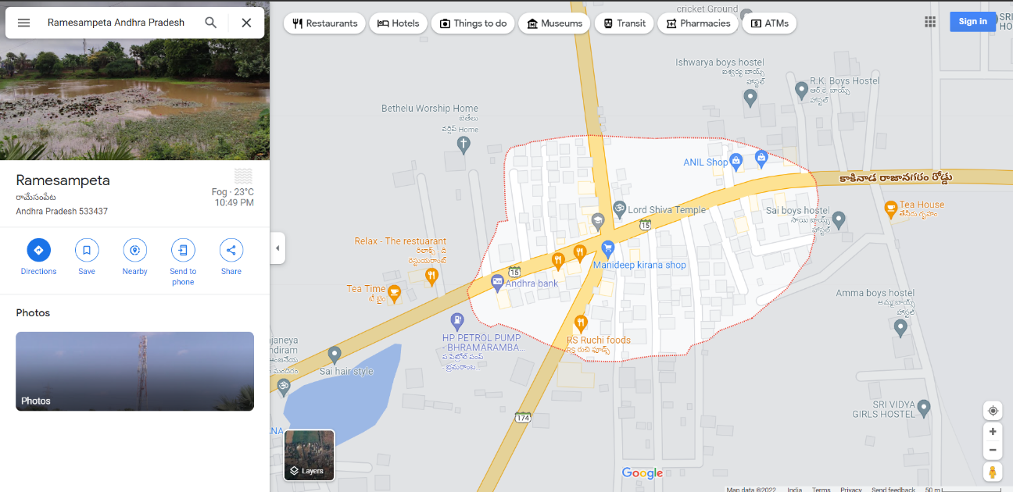

## In ramesampeta village population of children with age 0-6 in 332 which makes up 10.22% of total population of village.Average sex ratio of Ramesampeta village is 983 which is lower than Andhra Pradesh state average of 993.child sex ratio of Ramesampeta as per census is 919 lower than Andhra Pradesh Average of 939.

## Ramesampeta village has lower literacy rate compare to Andhra Pradesh.In 2011 literacy rate of was 53.56% compared to 60.59%of Andhra Pradesh in ramesampeta literacy stand at 61.38%while female literacy rate was 35.90%.

Ramesampeta village has population of 2345 of which 1800 are male.

**Steps followed to collect the information:**

1. **Identification of internet speed :**To collect the information which is required for us. We have interacted with staff of local Sachivalayam to know where the network towers are thare.

2. **Interaction with the people:** Our group had interacted with the people of the village and gathered the information about their usage of internet and speed of the internet near them.

3. **Filling the survey form:** By interacting with the people, we collected the information in the survey form. In this form we collected the information such as name of the person, village name, which SIM you are using, and the issues faced by the people while using internet.

4. I**dentifications of the problems:** By the information gathered in the survey form we identified many issues that are faced by the people.

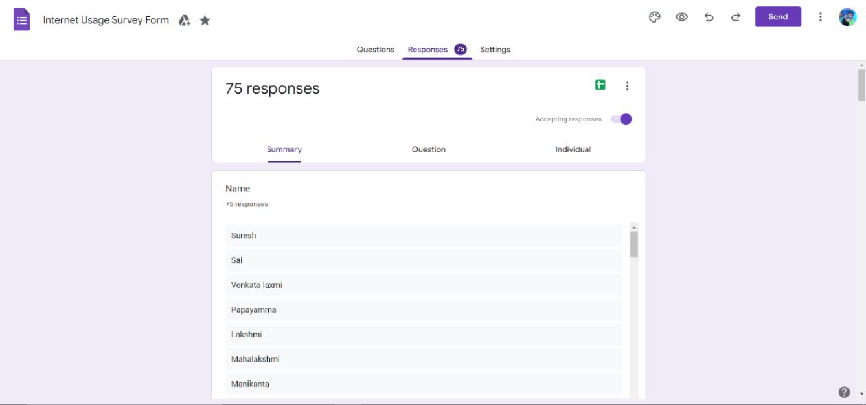

**Problems identified :**

1.Low source of internet connection .

2.speed of the internet.

3.Not knowing about privacy and security .

4.Not aware about online transaction .

**5. RECOMMENDATIONS AND CONCLUSIONS OF THE MINI PROJECT**

* Internet plays an important role to become digital.
* Now a days, Approximate 70-80% work is depend on internet like shopping, money transaction, … etc.
* Those who are not aware about internet and what are the uses of internet and what is the importance of internet not survive confidently.
* And those who are not knows about internet privacy/security definitely they face lot of problem because now a day threating rate increases day by day.
* That’s why we suggest many things to them and help them to aware about internet so that they also use internet properly.

**7. Student Self-Evaluation for the Community Service Project**

**Student Name : Sk.Rizwan**

**Registration No:21P31A05B5**

**Period of CSP: From: ____22.08.2022___________ To: ___04.09.2022____________**

**Date of Evaluation:14.12.2022**

**Please rate your performance in the following areas:**

**Rating Scale: Letter grade of CGPA calculation to be provided**

|  |  |  |  |  |  |  |
| --- | --- | --- | --- | --- | --- | --- |
| 1 | Oral communication | 1 | 2 | 3 | 4 | 5 |
| 2 | Written communication | 1 | 2 | 3 | 4 | 5 |
| 3 | Proactiveness | 1 | 2 | 3 | 4 | 5 |
| 4 | Interaction ability with community | 1 | 2 | 3 | 4 | 5 |
| 5 | Positive Attitude | 1 | 2 | 3 | 4 | 5 |
| 6 | Self-confidence | 1 | 2 | 3 | 4 | 5 |
| 7 | Ability to learn | 1 | 2 | 3 | 4 | 5 |
| 8 | Work Plan and organization | 1 | 2 | 3 | 4 | 5 |
| 9 | Professionalism | 1 | 2 | 3 | 4 | 5 |
| 10 | Creativity | 1 | 2 | 3 | 4 | 5 |
| 11 | Quality of work done | 1 | 2 | 3 | 4 | 5 |
| 12 | Time Management | 1 | 2 | 3 | 4 | 5 |
| 13 | Understanding the Community | 1 | 2 | 3 | 4 | 5 |
| 14 | Achievement of Desired Outcomes | 1 | 2 | 3 | 4 | 5 |
| **15** | **OVERALL PERFORMANCE** | **1** | **2** | **3** | **4** | **5** |

**Date:14.12.2022 Signature of the St**

### Evaluation by the Person in-charge in the Community /Habitation

**Student Name: Sk.Rizwan**

**Registration No:21P31A05B5**

**Period of CSP: From: _22.08.2022______________ To: __04.09.2022_____________**

**Date of Evaluation:14.12.2022**

**Name of the Person in-charge:**

**Address with mobile number:**

**Please rate the student’s performance in the following areas:**

Please note that your evaluation shall be done independent of the Student’s self- evaluation

**Rating Scale: 1 is lowest and 5 is highest rank**

|  |  |  |  |  |  |  |
| --- | --- | --- | --- | --- | --- | --- |
| 1 | Oral communication | 1 | 2 | 3 | 4 | 5 |
| 2 | Written communica0tion | 1 | 2 | 3 | 4 | 5 |
| 3 | Proactiveness | 1 | 2 | 3 | 4 | 5 |
| 4 | Interaction ability with community | 1 | 2 | 3 | 4 | 5 |
| 5 | Positive Attitude | 1 | 2 | 3 | 4 | 5 |
| 6 | Self-confidence | 1 | 2 | 3 | 4 | 5 |
| 7 | Ability to learn | 1 | 2 | 3 | 4 | 5 |
| 8 | Work Plan and organization | 1 | 2 | 3 | 4 | 5 |
| 9 | Professionalism | 1 | 2 | 3 | 4 | 5 |
| 10 | Creativity | 1 | 2 | 3 | 4 | 5 |
| 11 | Quality of work done | 1 | 2 | 3 | 4 | 5 |
| 12 | Time Management | 1 | 2 | 3 | 4 | 5 |
| 13 | Understanding the Community | 1 | 2 | 3 | 4 | 5 |
| 14 | Achievement of Desired Outcomes | 1 | 2 | 3 | 4 | 5 |
| **15** | **OVERALL PERFORMANCE** | **1** | **2** | **3** | **4** | **5** |

**Date:14.12.2022 Signature of the Person in-charge**

**9. PHOTOS & VIDEO LINKS**

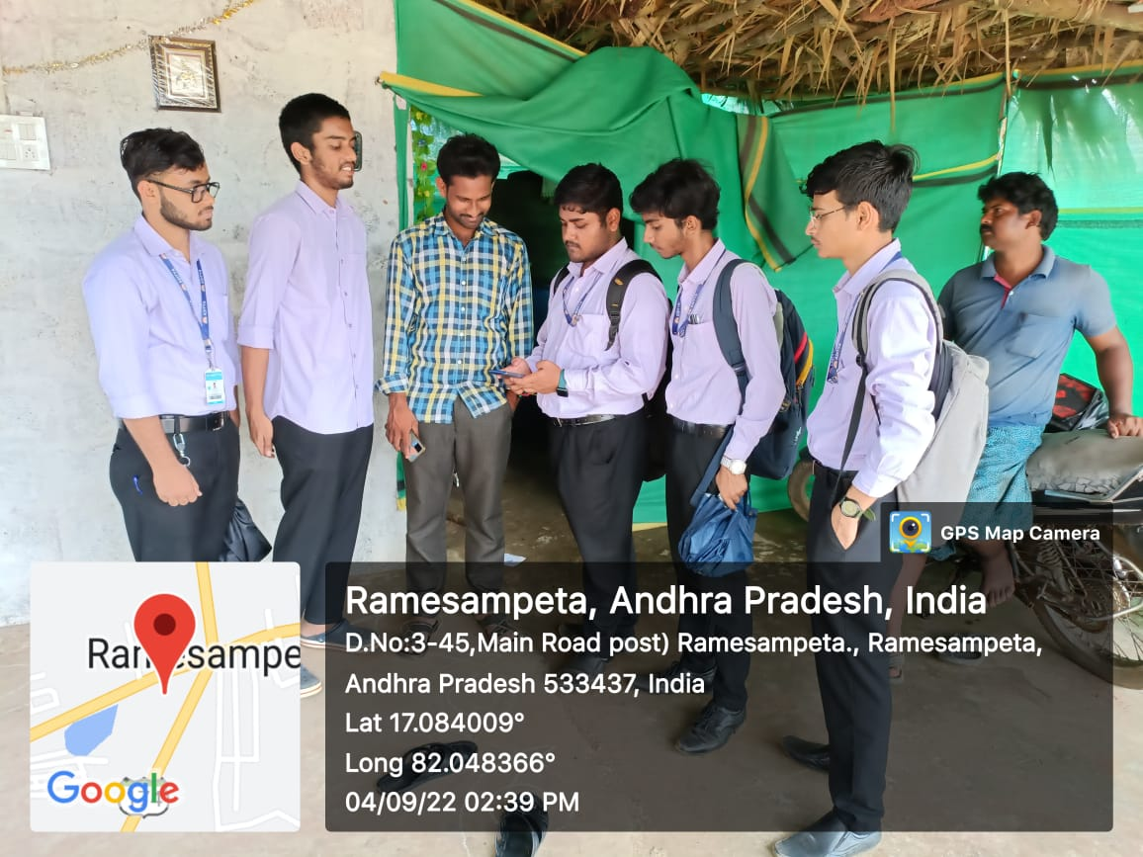

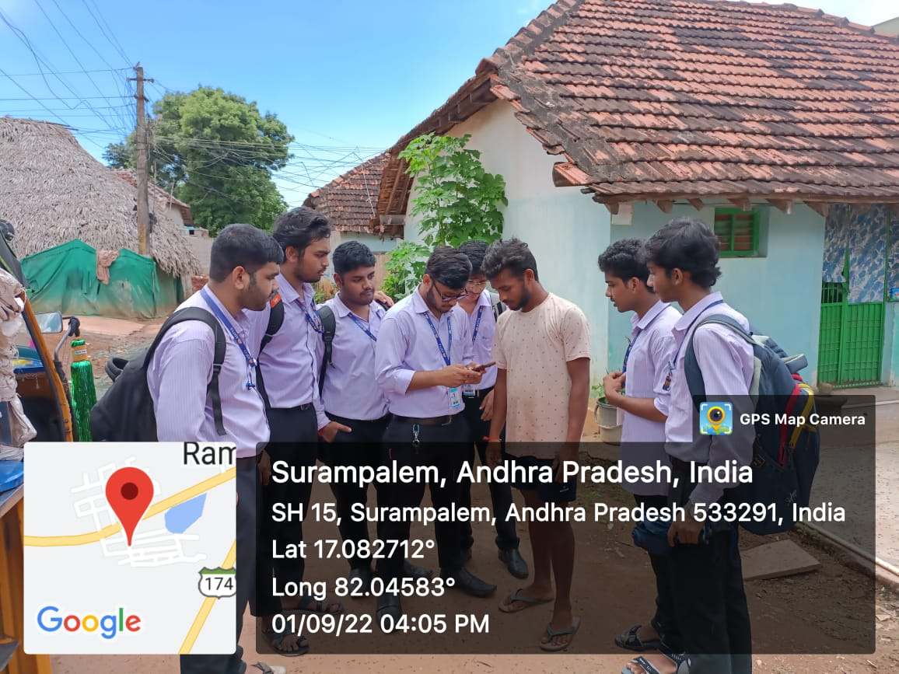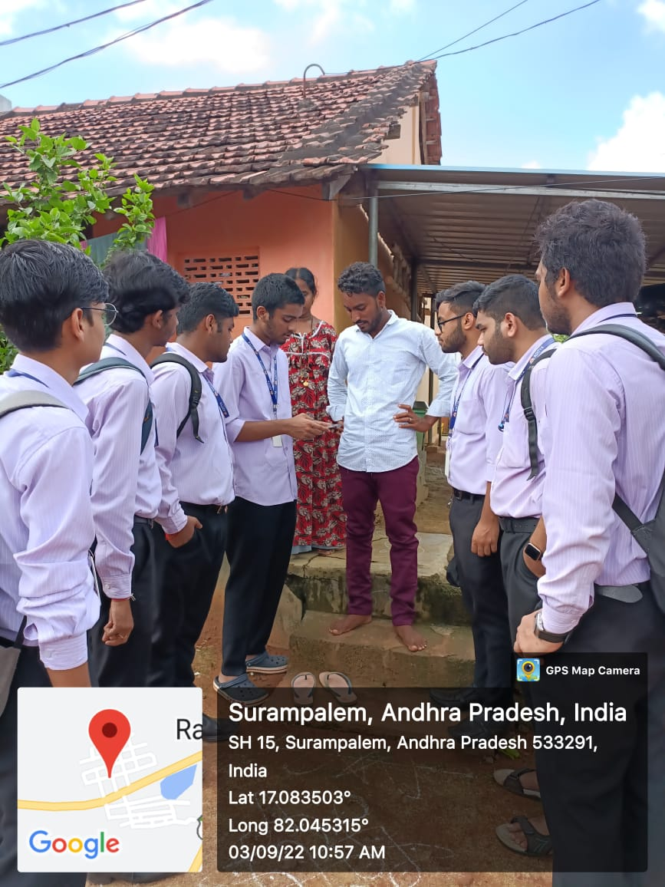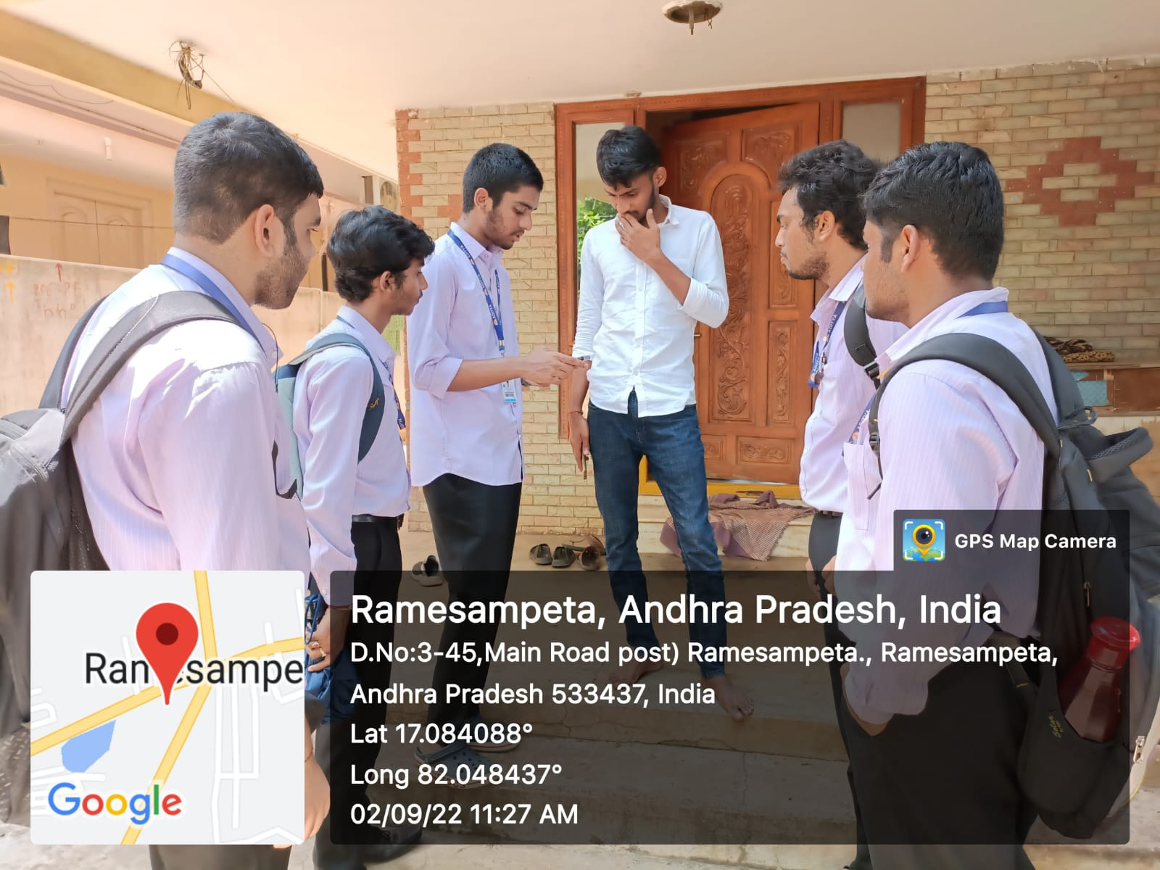

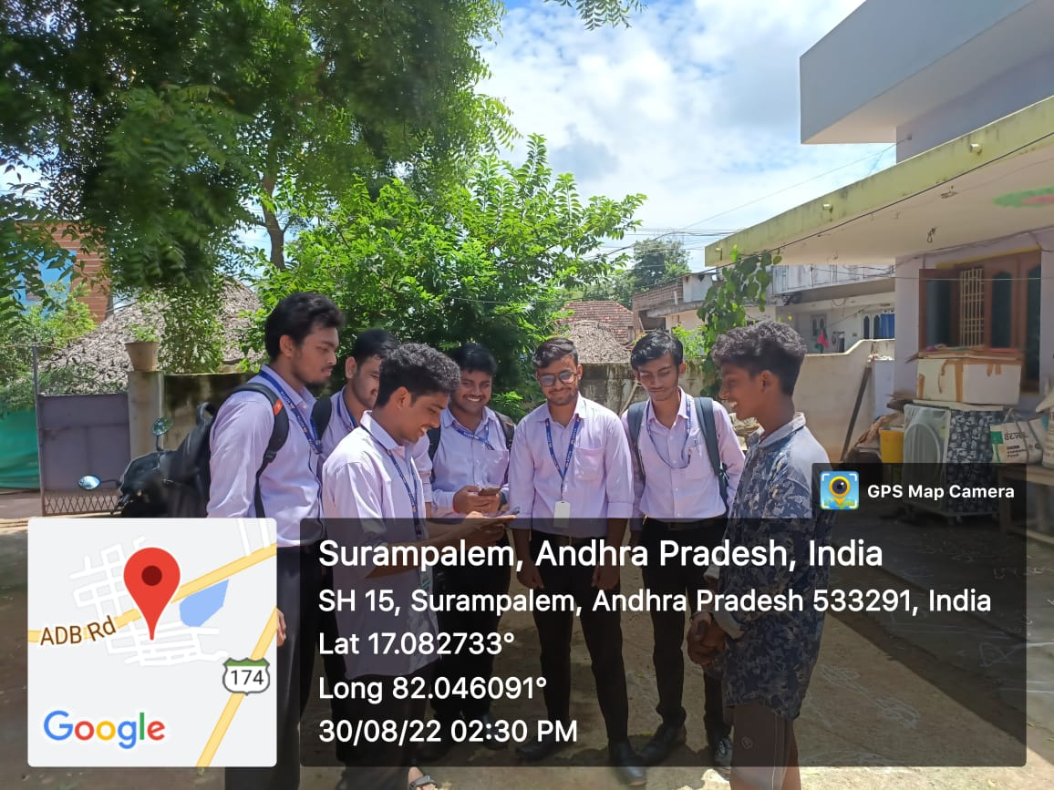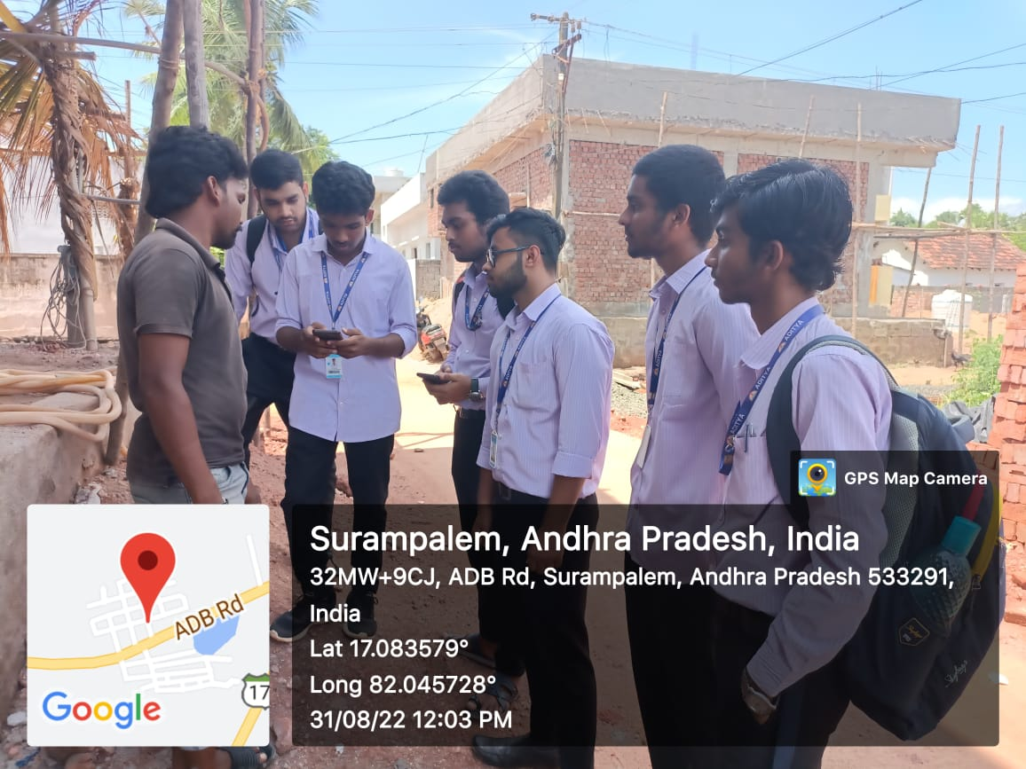

**10. INTERNAL ASSESSMENT STATEMENT**

**(To be used by the Examiners)**

**Name of the Student : Sk.Rizwan**

**Programme of Study : CSE**

**Year of Study : 2nd**

**Group : 1**

**Register No/H.T. No : 21P31A05B5**

**Name of the College : A C E T**

**University : JUNTUK**

|  |  |  |  |
| --- | --- | --- | --- |
| **Sl.No** | **Evaluation Criterion** | **Maximum Marks** | **Marks Awarded** |
| 1. | Activity Log | 20 |  |
| 2. | Community Service Project Implementation | 30 |  |
| 3. | Mini Project Work | 25 |  |
| 4. | Oral Presentation | 25 |  |
|  | **GRAND TOTAL** | 100 |  |

**Date:14.12.2022** **Signature of the Faculty Guide**

**Certified by**

**Date:14.12.2022** **Signature of the Head of the Department/Principal**

**Seal:**